System Integration Solution 36
A System Integration Solution


Introducing 2 NEW AV (Audio/Video/Data) Adapter Plates for our MPS-Lite series of connector panels, L-MPS-AV64 and L-MPS-AV64-F!

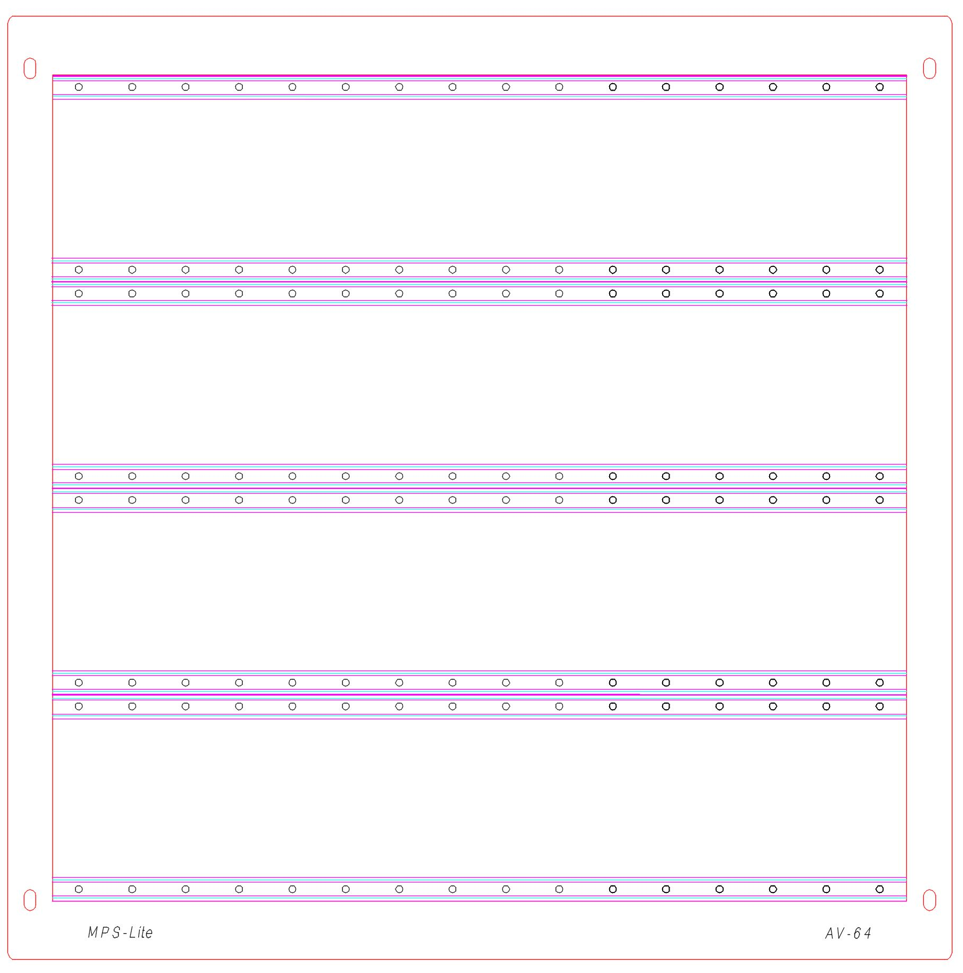
Both the AV-64 and AV64-F have been designed to be installed to the front of a 16” x 16” Hoffman ASE 16” x 16” x 6” Pull Box. The AV64 is used when the enclosure has been Surface Mounted and the AV64-F (Flush version) is used when the enclosure has been installed Inside the wall, behind the sheetrock.

Both Adapter Plates support 4 rows of 16MU for a total of 64MU per Adapter Plate. The 64 MPS-Lite Module Units (MU=0.905") can be made up of any combination of A (1MU), B (2MU), C (3MU), up to F(6MU) size panels. Visit our website to see the full list of connector options and hole cuts for our patch panels. Custom hole cuts and engravings are always welcome. Send us your designs and drawings to sales@sigt.com for a fast quote.

After the Hoffman ASE 16” x 16” x 6” Pull Box (readily available from many electrical wholesalers) has been installed the lift-off cover is replaced by either the AV64 or AV64-F Adapter Plate, depending on the type of installation.

The AV64 Adapter Plate is 16” x 16”, the same the same size as the Hoffman ASE 16” x 16” x 6” Pull Box enclosure, and fits without any overlap for Surface Mount Installation.

The AV64-F Adapter Plate is 17-1/2” x 17-1/2”, which allows for a generous overlap of the Hoffman ASE 16” x 16” x 6” Pull Box. This covers the cutout in the sheet rock allowing for clean In Wall Installations.
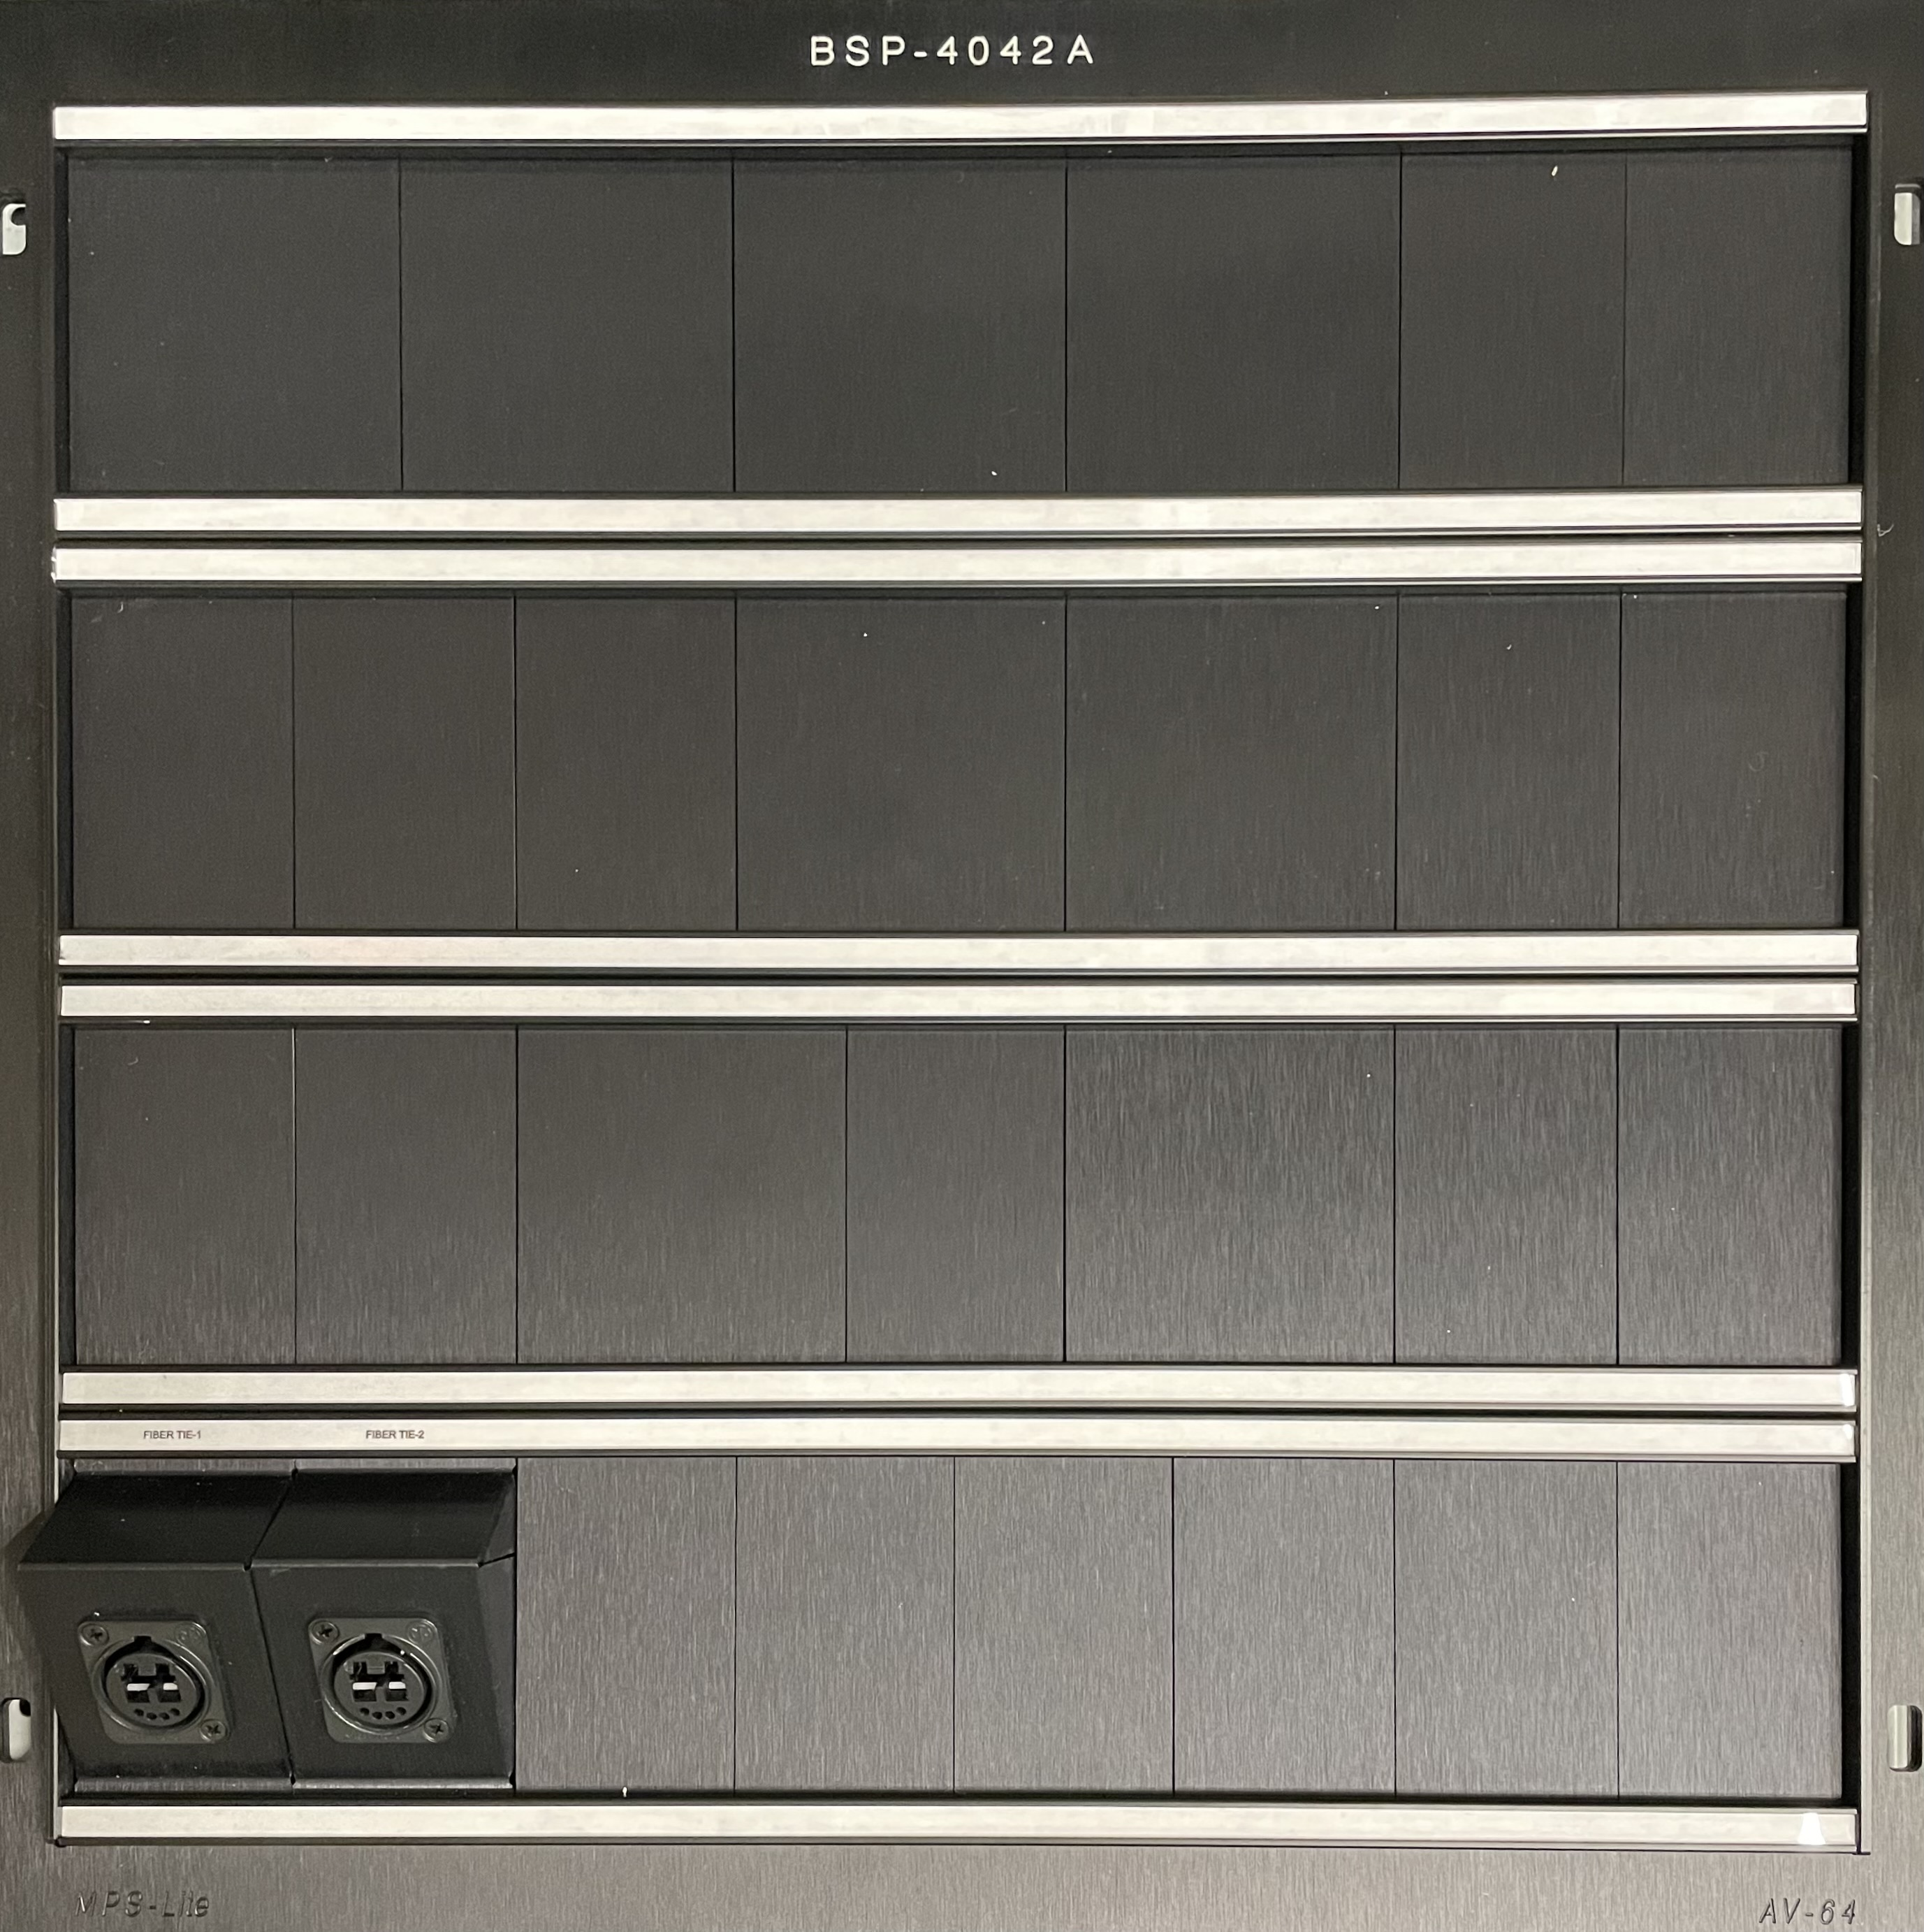
Each Adapter Plate is comprised of 3 parts. The Base Plate, a formed plate that can accommodate (4) rows of 16 MU’s, (2) Label End Stops that are attached to the Base Plate and a Face Plate. The face plate is installed over the Base Plate and label end stops, that collectively attached to the front face of the Hoffman ASE 16” x 16” x 6” pull box enclosure via 4 screws and provides the platform for the installation of our wide range of MPS-Lite modular panels.

The Adapter Plate is also supplied with (8) Label Strips that cover the MPS-Lite modular panels mounting screws and help identify the panel / connector function for the user. This results in a clean professional interface that can easily be upgraded to meet the demands of tomorrow. (Example layout, top of page)
The Adapter Plate assembly is supplied with anodized Black. As shown in the picture to the left. Custom powdered coated panels are also available. Send us an email at sales@sigt.com for a quote!
You can also email your request for the AutoCAD library to do your own layout using the embedded blocks for this AV product or our Rack and Wall Plate Adapters, plus a wide selection of MPS-Lite modular connector panels.
Visit our website at www.sigt.com – or give us a call at (714) 641-5665 for
information and pricing on all our products, Thanks you!

